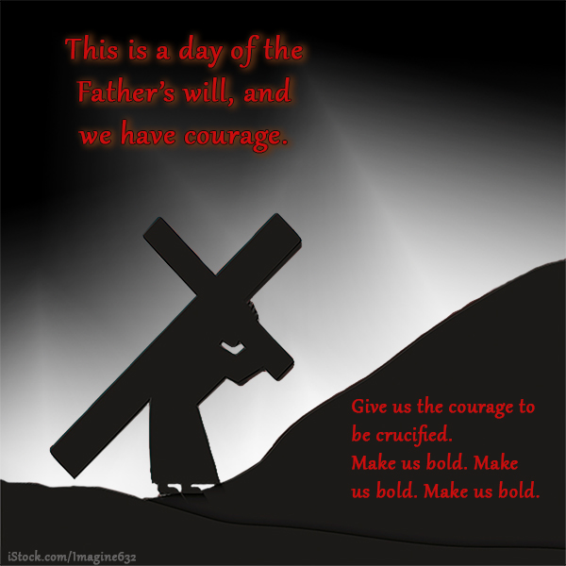
SYNC Readings for Courage Season
Read with “3D glasses”:
What is the DRUMBEAT, the pattern, the feel?
As I DANCE to that beat, how do I change?
What can I DELIVER to others from these verses?
 |  |  | New T. |  | Old T.
Su | Oct | 1 | Phil intro |  | Num. Intro
Mo | Oct | 2 | Phil | 1 | Num 1-4
Tu | Oct | 3 | Phil | 2 | Num 5-7
We | Oct | 4 | Review 1-2 |  | Num 8-10
Th | Oct | 5 | Phil | 3 | Num 11-13
Fr | Oct | 6 | Phil | 4 | Num 14-16
Sa | Oct | 7 | Review 3-4 |  | Num 17-19
Sun | Oct | 8 | 1 Tim intro |  | Rvw 1-19
Mo | Oct | 9 | 1 Tim | 1 | Num 20-21
Tu | Oct | 10 | 1 Tim | 2 | Num 22-24
We | Oct | 11 | 1 Tim | 3 | Num 25-27
Th | Oct | 12 | 1 Tim | 4 | Num 28-30
Fr | Oct | 13 | 1 Tim | 5 | Num 31-33
Sa | Oct | 14 | 1 Tim | 6 | Num 34-36
Sun | Oct | 15 | Review 1-6 |  | Rvw 20-36
Mo | Oct | 16 | 2 Tim | 1 | Ps Intro
Tu | Oct | 17 | 2 Tim | 2 | Ps 73-76
We | Oct | 18 | 2 Tim | 3 | Ps 77-78
Intro = an intro to the book (see Bible dictionary)
Th | Oct | 19 | 2 Tim | 4 | Deut Intro
Fr | Oct | 20 | Review 1-4 |  | Deut 1-3
Sa | Oct | 21 | Titus | 1 | Deut 4-6
Sun | Oct | 22 | Titus | 2 | Deut 7-9
Mo | Oct | 23 | Titus | 3 | Deut 10-12
Tu | Oct | 24 | Review 1-3 |  | Deut 13-16
We | Oct | 25 | Heb intro |  | Rvw 1-16
Th | Oct | 26 | Heb | 1 | Deut 17-20
Fr | Oct | 27 | Heb | 2 | Deut 21-23
Sa | Oct | 28 | Heb | 3 | Deut 24-27
Sun | Oct | 29 | Heb | 4 | Deut 28-30
Mo | Oct | 30 | Heb | 5 | Deut 31-32
Tu | Oct | 31 | Heb | 6 | Deut 33-34
We | Nov | 1 | Review 1-6 |  | Rvw 17-34
Th | Nov | 2 | Heb | 7 | Ps 79-82
Fr | Nov | 3 | Heb | 8 | Ps 83-86
Sa | Nov | 4 | Heb | 9 | Ps 87-89
Sun | Nov | 5 | Review 7-9 |  | Lam 1-2
Mo | Nov | 6 | Heb | 10 | Lam 3-5
Tu | Nov | 7 | Heb | 11 | Neh 1-3
We | Nov | 8 | Revw. 10-11 |  | Neh 4-7
Th | Nov | 9 | Heb | 12 | Neh 8-10
Fr | Nov | 10 | Heb | 13 | Neh 11-13
Sa | Nov | 11 | Revw. 12-13 |  | Rv Nov 2-10
Sun | Nov | 12 | 1 Pt intro |  | Est 1-3
Mo | Nov | 13 | 1 Pet | 1 | Est 4-7
Tu | Nov | 14 | 1 Pet | 2 | Est 8-10
We | Nov | 15 | 1 Pet | 3 | Rvw 1-10
Th | Nov | 16 | 1 Pet | 4 | Ps 90-93
Fr | Nov | 17 | 1 Pet | 5 | Ps 94-97
Sa | Nov | 18 | Review 1-5 |  | Ps 98-101
Sun | Nov | 19 | 2 Pet | 1 | Ps 102-04
Mo | Nov | 20 | 2 Pet | 2 | Ps 105-06
Tu | Nov | 21 | 2 Pet | 3 | Hab 1-3
We | Nov | 22 | Review 1-3 |  | Rv Nov 16-21
 | (Nov | 23 | Begin Glory Season)
Bold font = “do-not-miss” chapter of the week

